Mechanical Overview

Year: 2025 Semester: Spring Team: 20 Project: Encrypted USB Drive

Creation Date: ­2/15/2025 Last Modified: February 15, 2025

Author: Abhijay Achukola Email: aachukol@purdue.edu

Assignment Evaluation: See Rubric on Brightspace Assignment

* 1. Commercial Product Packaging
  2. Product #1

The DataLocker Sentry K350 16GB Encrypted USB Flash Drive Keypad is like our project and is packaged in a metal enclosure that is a bit more hefty than other USB drives. Its case has holes at the top with spaces for the individual keys to allow it to be pressed, and a space for the screen to display the current state of the device. The case also contains a cap of sorts to cover the USB-A male connector. 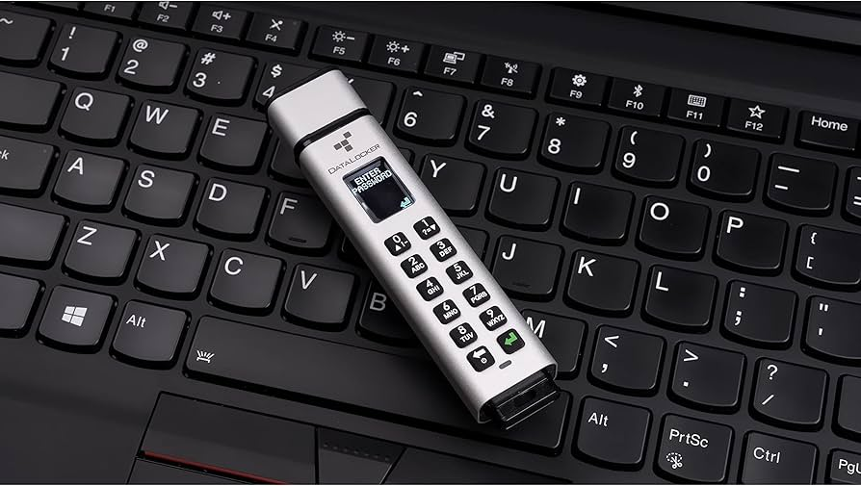

Our design will utilize some of the features from this device, while still removing some others. Utilizing the method of exposing the keys and display is what we’ll have in our device too, but instead of exposing individual keys, we’ll expose the entire matrix of keys, as the keys are fairly flat to the bottom of the keypad, so its better to expose every part of the part instead of making it harder for its users to click on the keys. We’ll use a female USB-A connector to prevent any issues of the male USB-A connector breaking under the weight of the device and provide a wire to connect it to devices. We’ll also utilize a plastic 3D printed enclosure for a more lightweight solution that is also easier to design and tweak.

* 1. Product #2

The 3-in-1 Fingerprint Encrypted USB 3.0 Drive – 64GB to 512GB Options is like our project and is packaged in a metal enclosure that is a bit more hefty than other USB drives and uses three male connectors instead of the standard one. Its case has one hole at the top with a bit of an indent for the fingerprint sensor, as well as three holes on the side, one for each connector. The casing is a bit weird shape, in a triangle/hexagonal like structure, possibly to minimize materials used and optimize use of all three connectors.

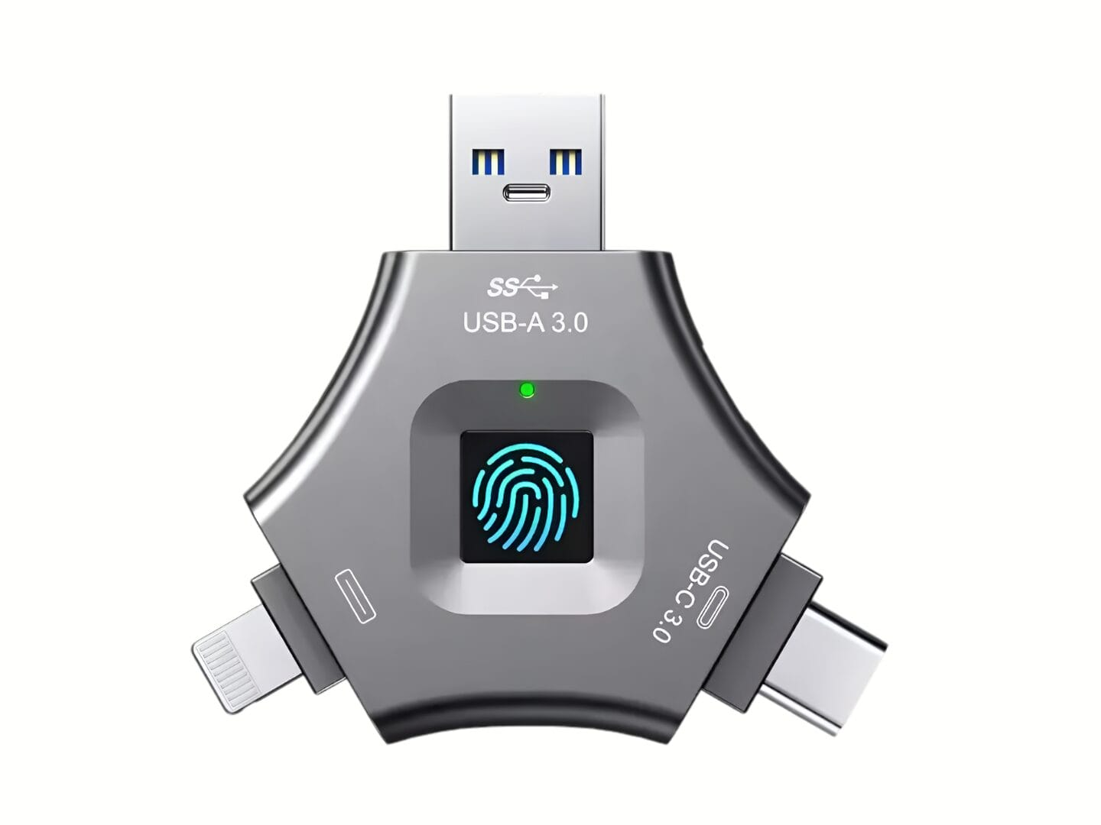

Our design will utilize some of the features from this device, while still removing some others. Utilizing the method of exposing the fingerprint is what we’ll have in our device too, but instead of exposing just the fingerprint surface, we’ll expose most of the surface to erase the need for the divot in the device. We’ll still use a single female USB-A connector and will instead use a rectangular packaging as there is no need to have space for three separate connectors.

2.0 Project Packaging Description

Our design packaging will consist of two main pieces, the top half of the 3D printed enclosure and the bottom half of the 3D printed enclosure, which will be screwed closed once the PCB for the device is secured within the enclosure. The material used will be ABS 3D printing filament. The top half of the enclosure will have a couple holes sized to fit the fingerprint sensor, the keypad, and the LCD screen, to allow the user to view and interact with them to utilize the device. It will also contain multiple holes on the top half that will screw into screw holes in the bottom half, sealing the device shut. The lower half of the enclosure will contain pegs that will fit into holes in the PCB to secure it in place. Also, both halves of the enclosure will come together leaving a hole in the front of the device to allow the female USB-A connector on the PCB to be accessible from outside of the package. The connector will remain inside the package, but the hole will allow access to the port to allow the device to be connected to computers. We’ll also include a male USB-A to male USB-A cable to allow for an extension wire to be able to interface with female USB-A ports on computers and other devices.

We chose to use a female USB-A port on our device due to mechanical worries and constraints, as our device will be fairly big and have a bit of weight to it, and a male USB-A cable could allow usage without an additional cable.to prevent the device from being damages by having to balance the entirety of the weight of the device on just the male USB-A connector on the PCB. We still are aiming to minimize the weight and size of the device, however, with a keypad, LCD, and fingerprint sensor, there is no way to make the device smaller than the individual components.

3.0 Sources Cited

[1] Amazon.com: DataLocker Sentry K350 16GB encrypted USB flash drive keypad, Easy Screen guided setup AES 256, TAA compliant ruggedized MIL-STD 810-G, IP68 OS independent, USB-A, FIPS 140-3 level 3 pending : Electronics, https://www.amazon.com/DataLocker-K350-Encrypted-USB-Drive/dp/B001FXH8J2 (accessed Feb. 15, 2025).

[2] “3-in-1 fingerprint encrypted USB 3.0 Drive - 64GB to 512GB options,” Sphere Resources, https://sphere-resources.com/product/fingerprint-encrypted-usb-drive/ (accessed Feb. 15, 2025).

Appendix 1: CAD Model Illustrations

Figure 1: An initial diagram of the casing we will be utilizing for our device, with specifications being altered based on dimensions.

Appendix 2: Project Packaging Specifications

|  |  |  |  |
| --- | --- | --- | --- |
| Material | Quantity | Estimated Weight | Estimated Cost |
| ABS 3D Printing Filament | 1 | 113.08 g (0.249 lbs) | $0.7 |
| Screws | 4 | 0.02 lbs | $0.75 |
| Total | N/A | 0.449 lbs | $1.45 |

* Requires:
  + 3D Printer: Free with Bechtel Innovation Design Center.

Appendix 3: PCB Footprint Layout

